

American International University-Bangladesh (AIUB)  
**Department of Computer Science and Engineering   
Faculty of Science &Technology (FST)  
Fall 20-21  
CSC 00191- Object Oriented Analysis And Design (OOAD)**

**Section: C**

**Project Title: RESTAURANT RESERVATION SYSTEM**

**Submitted by:**

|  |  |
| --- | --- |
| **Name** | **ID** |
| 1. **Noor Mohammad Talukder** | **19-40649-1** |
| 1. **Mohammad Maruful Islam** | **19-40135-1** |
| 1. **Ariful Islam Marfy** | **19-40116-1** |

**Submitted to:**

**MD. ANWARUL KABIR**

**Sr. Assistant Professor**

**Department of Computer Science**

# 1. Project Title: Restaurant Reservation System.

# 2. Project Overview: The project is about restaurant reservation system in which a particular customer can book table on a particular date. Advertisement is the main thing in business and sometime it is so much costly. Small restaurant cannot afford it. On the other hand present world is the time of social media there is so much food group where fake review which misleads the potential customer .There are some application for online food ordering but there is no good application for restaurant reservation. Project team make such a project where particular customer can book table on a particular date. Not only that restaurant company can show their offer and can attract the customers. Many component, feature and users are present in the project. They are given below:

**Component:**

* Database management component
* Location of restaurant
* Automatic review checking system

**Feature:**

* Registration
* Login
* Search restaurant
* Restaurant suggestion
* Food offer
* Booking table
* Viewing customer’s details
* See reviews
* Give reviews
* Payment option
* Confirming payment
* Maintaining ledger

**Users:**

* Customer
* Employee
* Manager
* Application administrative officer
* Account officer

3. Justification:The project is providing a platform which is about to create a virtual place for customers and restaurants. Here customers can access restaurant from online without any hassle. They can make their reservation and also get offers from the restaurants. Customers can access to independent reviews of the restaurants and their food items. From the restaurant side, they can update a promotional offer to the customers. Customers will receive a push notification in their app. For the inventory management there will be a desktop app for the restaurant account officer in which he can manage the whole system and inventory online and offline which will be much easier than doing it in excel. They will get the full graphical representation of their restaurant for easy table management. This project is aimed to ensure dedicated app for Restaurant owners and customers with latest android version. The objective is to make a two way communication platform.

4. Overall Use Case of the Proposed Project:Reserve Restaurant 24x7 is an application for restaurant reservation. In this application a customer and employee must login with verification. Customer register for use this platform. He can find restaurant suggestion or he can search any restaurant. A customer can also see reviews of restaurant and besides that he can also give reviews. Given reviews are allowed or disallowed by application administrative officer by judging them. A customer can also book table. Restaurant manager confirm the booking. Manager also can add offer for restaurant and after adding offer customer can see offer. Customer can pay by cash, bkash or card. Account officer confirm the payment. He also registers all things in ledger.

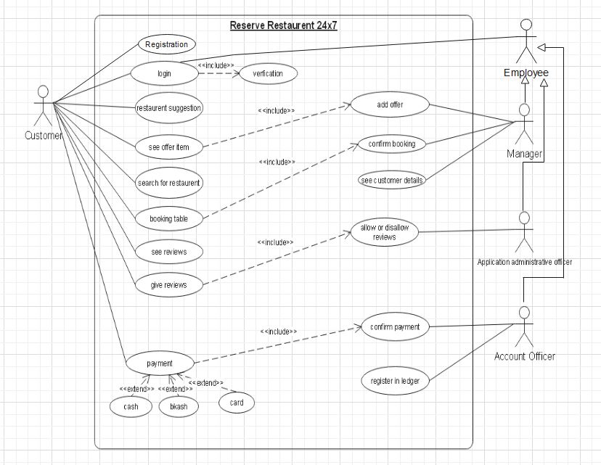

5. Class diagram of the project:

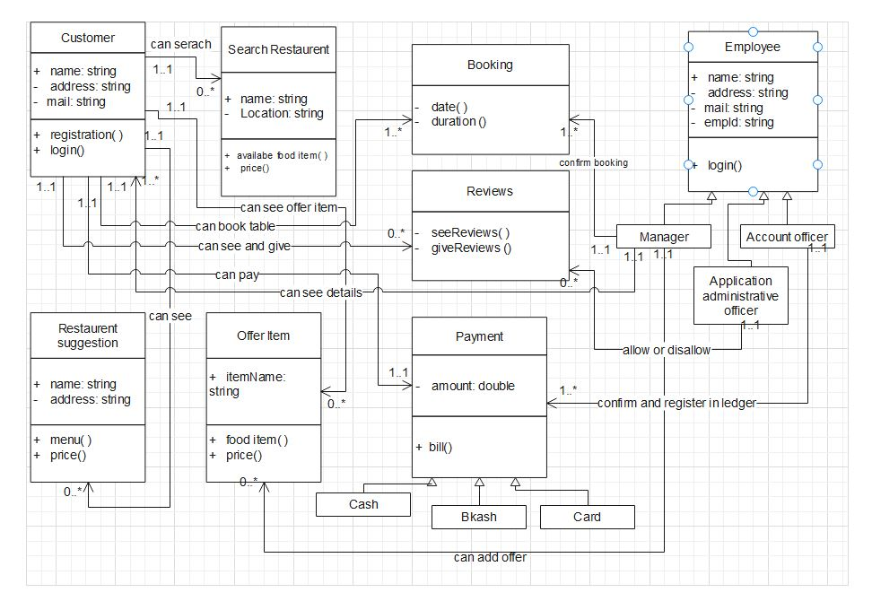

6. Activity Diagram of the project:

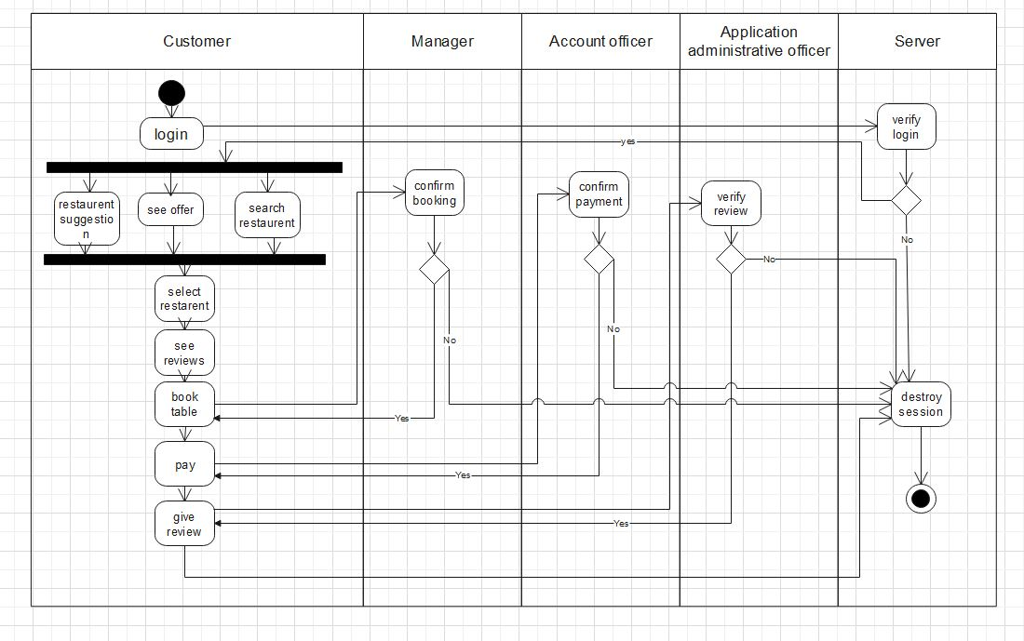

7. Sequence Diagram of the project

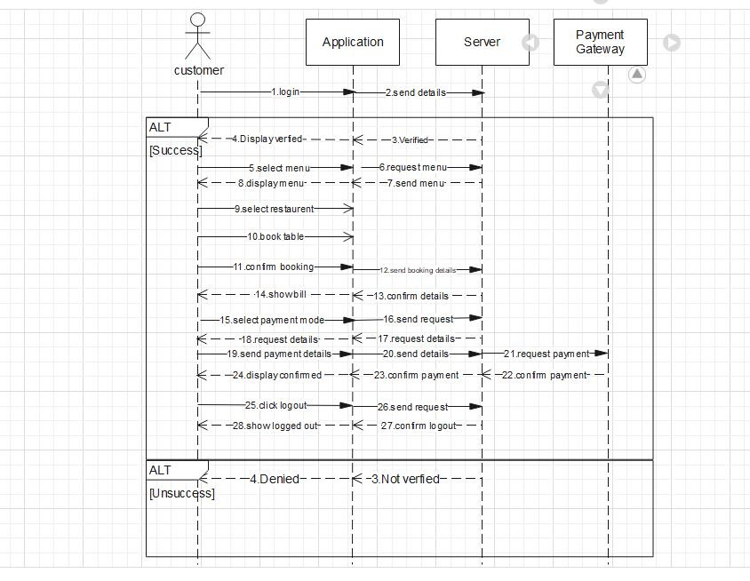

8. State chart Diagram:

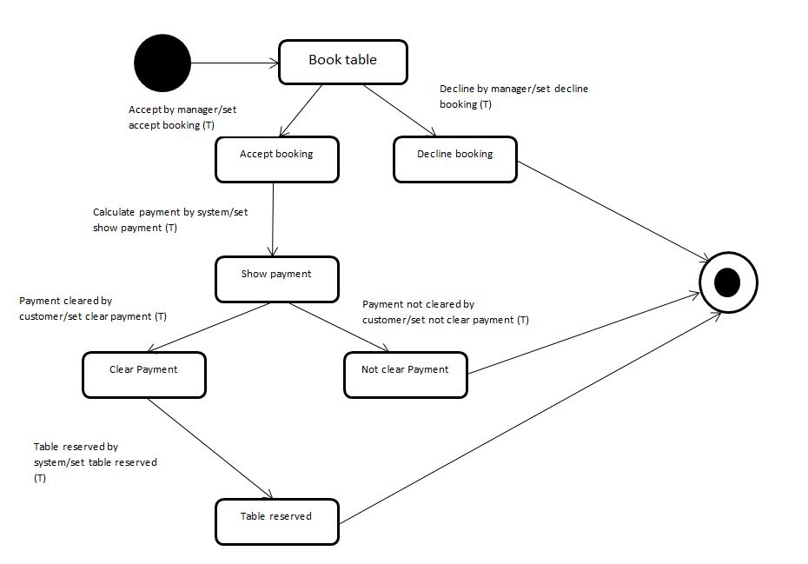

9. Conclusion: The aim of this project is to make the system of restaurant booking easy and cheap to the customer. Here we design various uml diagram to make the project and visual to the programmer who will code it in real time. Here we try to make the best use of resources and also we try to give the best facility to both customer and restaurant owner. Various change can be made here for future development.